Required Practical Activity:
Density 1

Note:
This resource is designed as a review of the required practical activity, covering all possible skills that could be developed through the investigation. This resource can be adapted to suit the needs of your class, depending on which skills your class need support with.

In this investigation we will use a ruler and balance to determine the density of a regularly shaped solid.

Method:

- Use the ruler to measure the length, width, and height of each of your selected regular shaped objects. Record this data in your results table.
- Calculate the volume of each object and record this in your results table also.
- Use the digital mass balance to measure the mass of each of your objects. Record this in your results table.
- Calculate and then record the density of the objects using the equation: density = mass/volume.
- Convert your density measurements into the standard units of kg/m³.

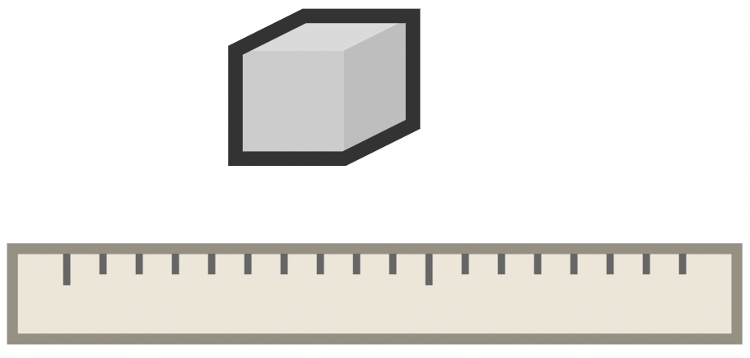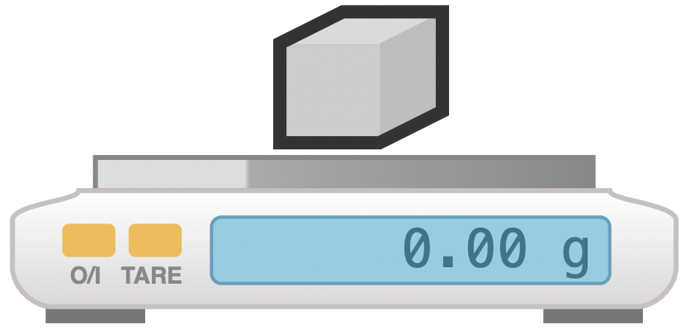

- Equipment:
- What measurements need to be taken in this investigation?
- What is the most suitable piece of apparatus to take measurements with? Why?
- Identify any hazards in this investigation.
- Why is it important that the balance is properly zeroed before weighing your object?

- What units will we use for mass, length, and volume?
- What is the difference between weight and mass?
- What is the equation for volume of a regular shaped object?
- What is the relationship between 1 cm³ and 1 ml?
- What is the equation to calculate density?
- What will be our units for density if we measure mass in grams (g) and length in centimetres (cm)?
- What are the S.I. units for density?

- Results

Regular  Shaped  object | Length (cm) | Width  (cm) | Height  (cm) | Volume (cm³) | Mass  (g) | Density  (g/cm³) | Density  (kg/m³)
Metal block | 3.0 | 2.0 | 2.0 | 12.0 | 100.0 | 8.300 | 8300
Wooden block | 4.0 | 3.0 | 3.0 | 36.0 | 21.9 | 0.608 | 608
Plastic block | 5.0 | 2.0 | 2.0 | 20.0 | 23.1 | 1.155 | 1155
Foam block | 6.0 | 6.0 | 6.0 | 216.0 | 4.3 | 0.020 | 20

- Explain why it is appropriate to round measurements taken with a ruler to the nearest millimetre.
- Which object had the highest density?
- Which object had the lowest density?
- Given the density of water is 1 g/cm³, which objects would you expect to float in water?

